
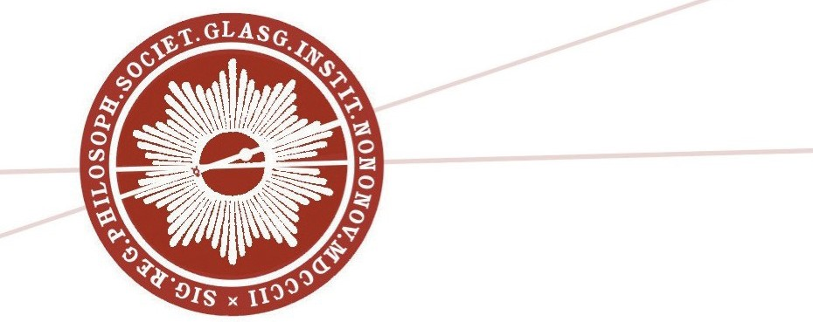
THE ROYAL PHILOSOPHICAL SOCIETY OF GLASGOW
15 Lanark Street, Glasgow G1 5PY

Membership Application/Renewal

cottish Charitable Incorporated Organisation No. SC015557
New application
Renewal
Student/under 25

Please print the information requested below:
Title: ............... First name(s): ............................. Family name: ...................................................
Address: ............................................................................................ Postcode: .................................
Telephone:..................................................... e-mail: ........................................................
Titles and name of other applicants at the same address: ...........................................................................

I/We hereby apply to join the Royal Philosophical Society of Glasgow Signature:................................................................ Date: ............................
Membership Rates for the year from August 2023 to July 2024
Full Subscription: £30 Concessions (over 65 or unemployed): £25

Free membership for students and those aged 25 and under on production of a current matriculation card or evidence of date of birth

NB: •. As all payments will be treated as Gift Aid, you may be liable if you do not pay UK income tax. If you are not eligible please add a cross to the box.
•. No application for new or renewed membership will be considered without a cheque or completed Direct Debit form for the relevant subscription.
•. Membership records will be retained in the Society’s archives and will not be used for any external purpose.
•.We only use your personal information to administer your membership and to provide the services of the Society.
Please complete the Direct Debit form below or attach a cheque for the full amount due.

Instruction to your bank or building society to pay by DirectDebit
Name(s) of account holders:...........................................................................
Bank/building society account number: ......................................... Branch sort code: ........–..........–..........
To: The Manager
Name of bank/building society: ........................................................................................................
Full address & postcode: ..................................................................................................................
Instructions to your bank or building society
Please pay The Royal Philosophical Society of Glasgow Direct Debits from the account detailed in this Instruction subject to the safeguards assured by the Direct Debit Guarantee. I understand that this Instruction may remain with The Royal Philosophical Society of Glasgow and, if so, details will be passed electronically to my bank/building society.
Signature:........................................................... Date: ............................
Banks and building societies may not accept Direct Debit Instructions for some types of account.

For RPSG use only Reference: RPSG 00 _ _ _ _ Service user number:

The Direct Debit Guarantee
260273

- This Guarantee is offered by all banks and building societies that accept instructions to pay Direct Debits
- If there are any changes to the amount, date or frequency of your Direct Debit The Royal Philosophical Society of Glasgow willnotify you 10 working days in advance of your account being debited or as otherwise agreed.
- If an error is made in the payment of your Direct Debit, by The Royal Philosophical Society of Glasgow or your bank or building society, you are entitled to a full and immediate refund of the amount paid from your bank or building society.
- You can cancel a Direct Debit at any time by simply contacting your bank or building society. Written confirmation may be required. Please also notify us.
Please ensure you have signed both parts of this form, and return to:
THE ROYAL PHILOSOPHICAL SOCIETY OF GLASGOW, 15 Lanark Street, Glasgow G1 5PY

